Learning Improvements

Unlocking Your Intuition: How to Solve Hard Problems Easily
Intuition can be thought of as the fast side of your brain. It allows you to instantly recognise patterns or solutions without deliberate thought. For example, when you look at a chair, you don’t consciously analyse what it is; you simply know it's a chair. This type of automatic recognition also applies to problem-solving, such as when you encounter coding challenges like those on Leetcode or HackerRank.
When you look at a coding problem, you might immediately know the solution approach—like using a hashmap and a loop. This is your intuition at work.

The Nature of Intuition
It’s important to understand that intuition is built on past knowledge and experience. It’s not useful when faced with completely new problems that have no connection to things you’ve already solved. Intuition works best when the problem shares similarities or concepts with previous problems you've encountered. For example, problems like "Two Sum" and "Contains Duplicate" are both solved using for-loop iteration, which taps into your existing intuitive knowledge.

How to Improve Your Intuition
Improving your intuition involves building stronger connections between problems and solutions, so your brain can recognise patterns more efficiently.

1. Create a Mapping Between Problems and Solutions
One effective way to strengthen your intuition is by consistently practising problem-solving and connecting problems to their solutions. Here’s how you can do it:
- Read the problem description carefully.
- Immediately check the solution to understand how it works.
By doing this regularly, you’ll achieve the following:
- Gain intuition for a wide range of problem types.
- Identify similarities and patterns between solutions to different problems.

2. Focus on Problem Components
Instead of memorising solutions, focus on understanding the components of problems and how they fit together in solutions. These components could include:
- Data structures: such as hashmaps, arrays, trees, or graphs.
- Time complexity: understanding Big O notation and how it applies to your solutions.
- Problem patterns: like dividing arrays into chunks or using past results to determine future outcomes.
By identifying these core components, you'll be able to recognise when a new problem shares similar traits with a previously solved one, helping you quickly identify potential solutions.

3. Ask Critical Questions
As you go through problems, ask yourself questions to deepen your understanding of the solution:
- Why does the solution work?
- What are the edge cases, and how does the solution handle them?
- Are there alternative ways to solve this problem?
These questions encourage you to engage with the solution beyond just memorisation, fostering deeper understanding.

The Role of Logic and Reasoning
To make the most of your intuition, you need a strong foundation of logic and reasoning. This is something you develop by solving problems yourself, or at least by attempting to solve them independently before looking at the solution. The more you challenge yourself to connect a problem with a solution, the sharper your intuition will become.

Building Your Own Connections
Attempting to solve a problem yourself forces you to think critically about the problem's structure and potential solutions. The connections you make in this process will help you recognise similar problems in the future, making your intuition more reliable.

Testing Your Intuition
Once you've developed some intuition, you can test it by approaching problems in a more structured way:
- Look at the problem and come up with high-level ideas for solutions.
- Check the actual solution to see if your ideas were correct.
- Reflect on why your ideas worked—or didn’t work—to refine your understanding.
This process not only improves your intuition but also helps you understand the reasoning behind successful solutions.

How to Awaken & Enhance Your Analytical Problem-Solving Mind
Creative problem solving is the ability to come up with novel solutions to problems—solutions that are original at least to you. For example, solving The Minion Game on HackerRank without having previously encountered the problem or seen anyone else’s solution is an act of creative problem solving.
It involves thinking beyond conventional patterns and generating unique ideas or approaches to reach a solution.

The Creative Process in the Brain
The process of creativity in the brain can be broken down into three main components:

1. Generator
- The generator produces a wide range of ideas—good, bad, or completely unrealistic.
- This happens mostly subconsciously and uncontrollably.
- The ideas generated are random and reflect both past experiences and spontaneous thoughts.

2. Filter
- The filter evaluates the ideas from the generator, selecting only the useful or promising ones.
- It controls how much effort is put into refining existing ideas or producing new ones.
- Turning the filter up or down determines how conventional or creative your thinking becomes.

3. Explorer
- Once good ideas pass through the filter, the explorer develops them further.
- It adds detail, logic, and feasibility to the idea, making it workable as a solution.
- The explorer is where high-level ideas are shaped into actionable plans.

Experienced vs. Inexperienced Problem Solvers
- Experienced individuals generate more relevant ideas, filter more effectively, and explore more quickly.
- They rely on a wider bank of past problems, allowing them to arrive at innovative yet grounded solutions faster.

Improving Your Creativity

1. Short-Term Creativity
This refers to the ability to come up with as many good ideas as possible in a short timeframe, especially while working on a specific problem.

Strategies to Improve Short-Term Creativity:
- Turn off your internal filter temporarily: Write down or mentally consider every idea, even if it seems silly or unrelated.
- Break your standard thinking patterns: The more stuck you feel, the more you should relax your filter. Sometimes unusual ideas lead to breakthroughs.
- Shift from experience to creativity:
  - At the start, rely on past experience to solve the problem.
  - Towards the end, when stuck, switch to exploring more unconventional or creative ideas.
- Experiment with different types of thinking:
  - Insight thinking: Sudden realisations.
  - Divergent thinking: Generating multiple ideas or possibilities.
  - Convergent thinking: Narrowing down ideas to the best one.
- Use small test cases: Focus on a single case or input before expanding to others.
- Explore variations: Try slight changes in the problem or reframe it to spark new approaches.
- Take short breaks: Stepping away briefly can reset your thinking and unlock fresh perspectives.

2. Long-Term Creativity
This is about training your brain over time to become more creatively inclined across a range of situations.

Strategies to Improve Long-Term Creativity:
- Expose yourself to more problems: The more varied your experiences, the more your generator has to draw from.
- Seek out unfamiliar challenges: Throw yourself into problems where standard solutions don’t apply.
- Push your limits:
  - Work on a problem until you solve it or until you're too mentally fatigued.
  - This builds endurance and deeper creative capacity over time.=

Focusing Your Unconscious Mind: Learn Hard Concepts Intuitively (And Forever)
This guide outlines a systematic method for deeply understanding and mastering a concept or problem. Rather than relying on memorisation, the focus is on developing real insight and flexible problem-solving ability through analysis, exploration, and reinforcement.

Step 1: Generate Insights from Experience
Start by drawing on your past experiences with similar problems. For example, with a topic like addition, you might recall concepts such as:
- Carrying over digits
- Adding digit by digit
- Understanding place value
🔑 Most importantly, care about what you’re learning.
This could be:
- Intrinsic interest – You find the topic genuinely engaging (the most effective motivation).
- Extrinsic motivation – You’re driven by an outcome (e.g. exams, job, personal goal).

Step 2: Understand Small Pieces at a Time
Break the concept or problem down into smaller components. Avoid overwhelming yourself by trying to grasp everything at once.
- Focus on one idea or step at a time.
- Only move on once you understand the current piece fully.
- Keep breaking things down until no further simplification is possible.

Step 3: Forget Memorisation – Focus on Understanding
Avoid rote learning. Instead, follow this multi-stage understanding method:

1. Understand the Big Picture
- Begin by looking at what the function or solution does.
- Use a simple one-line explanation of the input/output relationship.
- Don’t worry (yet) about how it works—just know what the solution achieves.

2. Dive into the Details
- Start with context: What’s the problem, and why does it matter?
- Then look at how each part works individually.
- Reinforce understanding by asking:
  - What is this piece doing?
  - Why is it needed?

3. Break It into Subproblems
- Each component becomes a small learning target.
- Keep going until you have a complete understanding of how the entire solution is built from simpler blocks.

Deepening Your Understanding: A More Detailed Guide

Step 1: Deeply Understand the Problem
- Before attempting the solution, spend time thinking critically about the problem.
- Ask:
  - What is this problem trying to accomplish?
  - Can I figure it out myself?
- Try solving it multiple times before giving up. Push yourself until:
  - You solve it, or
  - You genuinely burn out—then it’s time to check the solution.
Once you look at the solution, deconstruct it into small, understandable components.

Step 2: Understand Why the Solution Works
- Don’t stop at how it works—ask why.
- Example: If the solution sorts an array, ask:
  - Why does sorting help here?
  - What is sorting achieving in the context of the problem?

Step 3: Apply Real Effort
- Make sure you truly try to understand and solve the problem—not just a half-hearted attempt.
- Set a time limit to encourage focus and effort.

Reinforcement Techniques
To solidify what you've learned, use the following strategies:

1. Invent the Solution Yourself
- Use the method outlined above to reconstruct the solution on your own, based only on the problem statement.
- This builds both understanding and recall.

2. Practice on Related Problems
- Apply the same solution or concept to similar problems.
- Reflect on:
  - Where it fits.
  - Where it fails.
  - Why it works in one case but not another.

3. Explain It to Others (or to Yourself)
- Write the solution from scratch, explaining each part in simple terms.
- Imagine you’re teaching it to someone with no prior knowledge.
- This is one of the best tests of true understanding.

Exploration and Conceptual Flexibility

1. Change the Concept
- Modify the concept or approach slightly—does it still work?
- Ask yourself:
  - If I change this input, will the same logic hold?
  - Does the original solution still apply?

2. Explore Alternative Solutions
- Are there better or worse solutions?
- Try relating this solution to:
  - A past problem you've solved.
  - A concept you've previously studied.

3. Test with Edge Cases
- Use weird, extreme, or minimal examples to challenge the idea.
- Try to break the concept—does it still hold up?

4. Seek Other Perspectives
- Discuss the problem or solution with others.
- Ask:
  - Why does this method work?
  - Is there another way to approach it?
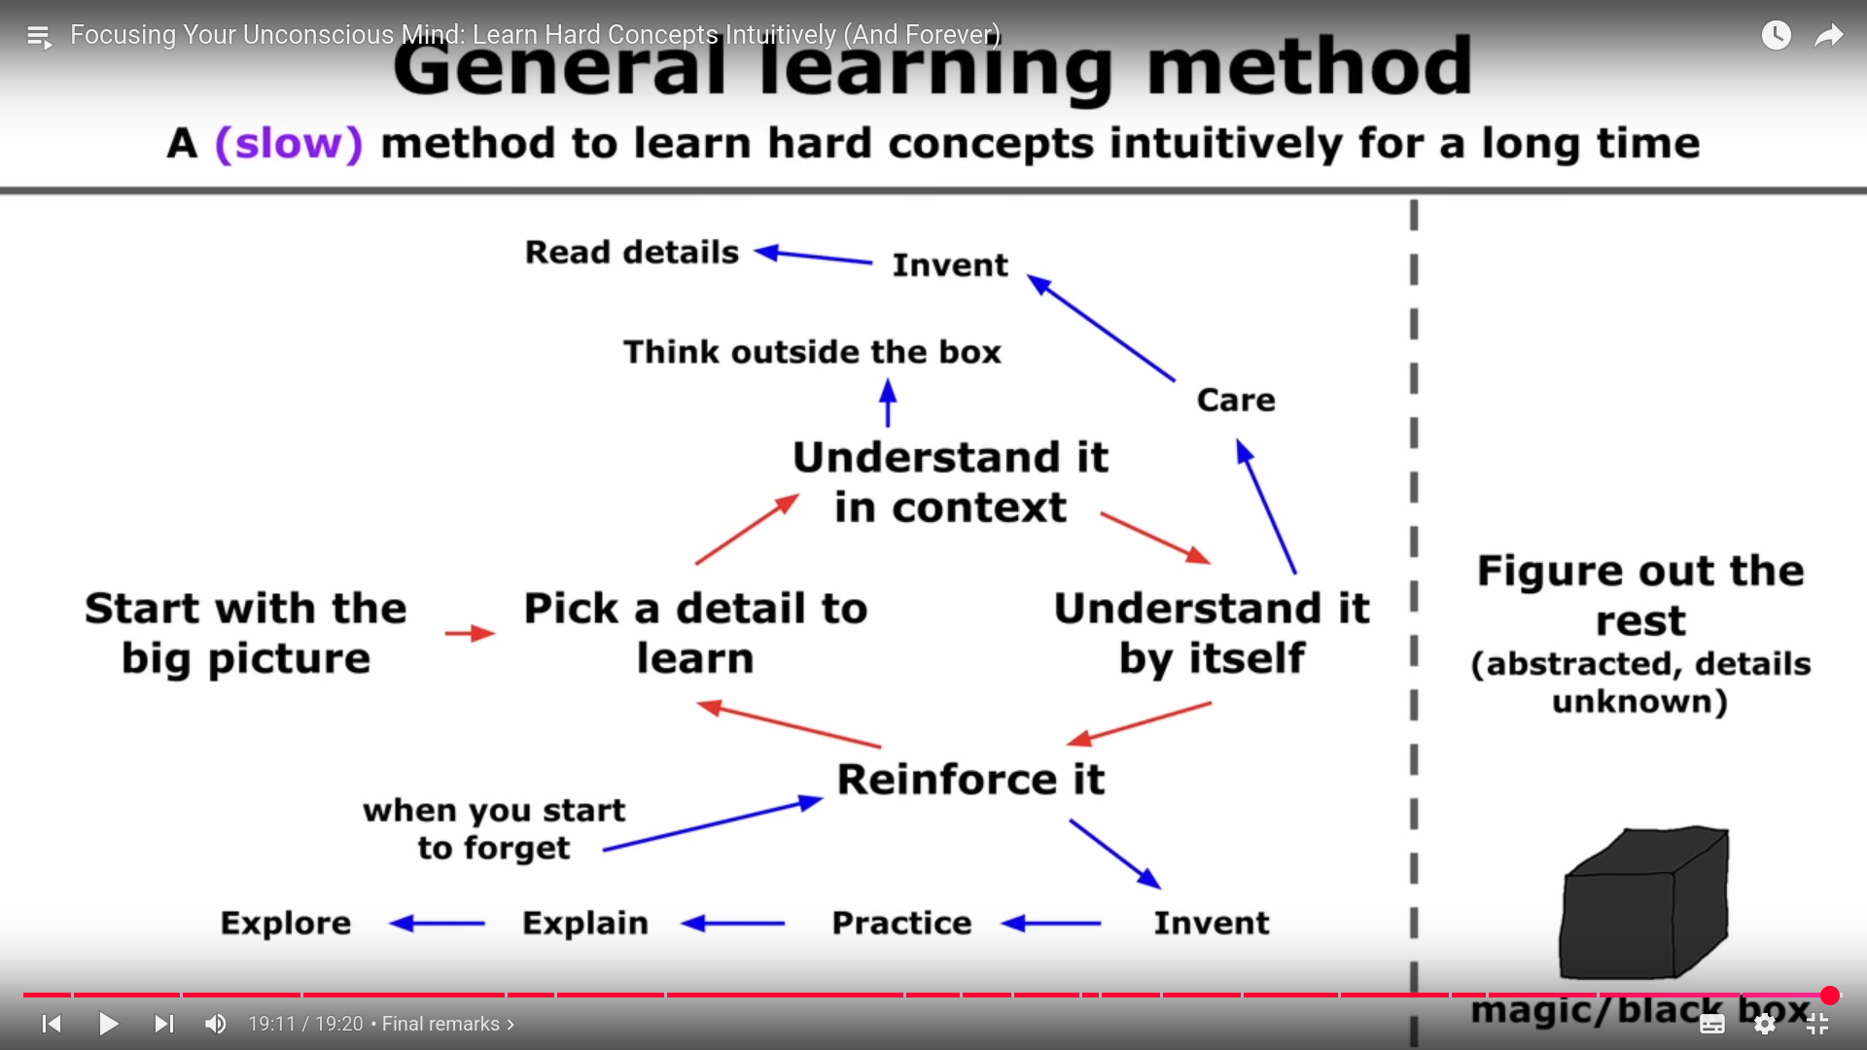

3-Minute Mental Hack to Take Control of Your Subconscious

Understanding the Subconscious Mind
- Your unconscious mind operates automatically in the background.
- It is responsible for intuition, insight, and behaviors you don't consciously think about.

How to Influence the Subconscious

1. Connect Tasks to Primal Emotions
- The subconscious responds strongly to primal emotions like:
  - Happiness
  - Fear
  - Survival
- To influence it, you must make yourself care deeply about your goals by linking them to one or more of these emotions.

2. Recognize the Emotional Core of Your Goals
- All arbitrary goals (e.g., doing LeetCode or applying for jobs) must be emotionally meaningful.
- These goals should converge on:
  - A sense of purpose
  - A primal emotional reward (like happiness or safety)

Applying This to Your Life

Your Ultimate Goal
- Get a job → Make money → Retire or live freely
  - So you can go climbing, walking, and do what makes you happy.

Daily Action Plan
- When working on tasks like:
  - LeetCode
  - HackerRank
  - GetCracked.io
  - Resume writing
  - LinkedIn or GitHub updates
- Associate each task with your ultimate emotional motivation:
  - Freedom
  - Happiness
  - Adventure

Reinforce the Connection

Focus While Working
- While doing a task, visualize the end goal (e.g., being on a mountain trail, feeling free and happy).
- Keep reminding yourself:
"This is taking me closer to the life I want."

Reward Yourself
- After each meaningful task or work session:
  - Reward yourself, even in small ways (a break, snack, short walk).
  - Do this a few times per day to reinforce the positive loop.

